Supplementary Material
Supplementary Table 1. Summary of MR results for prioritized genes across omics layers.
Gene | Omics layer | No. of SNPs | IVW OR (95% CI), P | MR-Egger OR  (95% CI), P | Weighted median OR (95% CI), P | IVW heterogeneity P | Egger intercept P | Notes / priority
HMG20B | pQTL | 24 | 1.229 (1.026-1.472),  P = 0.0248 | 1.487 (1.100-2.010),  P = 0.0171 | 1.176 (0.943-1.468),  P = 0.1502 | 0.0555 | 0.1428 | Primary pQTL evidence; interpret with caution because heterogeneity was borderline.
HDHD3 | pQTL | 20 | 1.217 (1.075-1.377),  P = 0.0020 | 1.143 (0.900-1.452),  P = 0.2862 | 1.211 (1.031-1.423),  P = 0.0196 | 0.6184 | 0.5577 | Strongest pQTL evidence; concordant positive estimates and no obvious heterogeneity or pleiotropy.
HMG20B | eQTL | 5 | 1.324 (1.055-1.662),  P = 0.0154 | 1.467 (0.939-2.289),  P = 0.1905 | 1.230 (0.928-1.629),  P = 0.1493 | 0.7571 | 0.6374 | Supportive eQTL evidence.
HDHD3 | eQTL | 3 | 1.078 (1.011-1.150),  P = 0.0225 | 0.981 (0.848-1.135),  P = 0.8402 | 1.071 (1.006-1.141),  P = 0.0324 | 0.3486 | 0.3939 | Supportive eQTL evidence; limited by a small number of instruments.
CI, confidence interval; eQTL, expression quantitative trait locus; IVW, inverse-variance weighted; MR, Mendelian randomization; OR, odds ratio; pQTL, protein quantitative trait locus; SNP, single nucleotide polymorphism.

Supplementary Table 2. Sensitivity analyses for the pQTL-based MR analyses of HMG20B and HDHD3.
Gene | Omics layer | IVW heterogeneity | MR-Egger heterogeneity | MR-Egger intercept | Interpretive note | MR-PRESSO global test
HMG20B | pQTL | Q = 34.716, df = 23,  P = 0.0555 | Q = 31.418, df = 22,  P = 0.0879 | -0.0158 (SE 0.0104),  P = 0.1428 | Leave-one-out analysis was visually stable. Funnel plot retained because heterogeneity was borderline. | P = 0.079
HDHD3 | pQTL | Q = 16.578, df = 19,  P = 0.6184 | Q = 16.221, df = 18,  P = 0.5771 | 0.0061 (SE 0.0102),  P = 0.5577 | Leave-one-out analysis was visually stable. No obvious heterogeneity or directional pleiotropy was detected. | P = 0.552
IVW, inverse-variance weighted; MR, Mendelian randomization; MR-PRESSO, Mendelian Randomization Pleiotropy RESidual Sum and Outlier; pQTL, protein quantitative trait locus; SE, standard error.

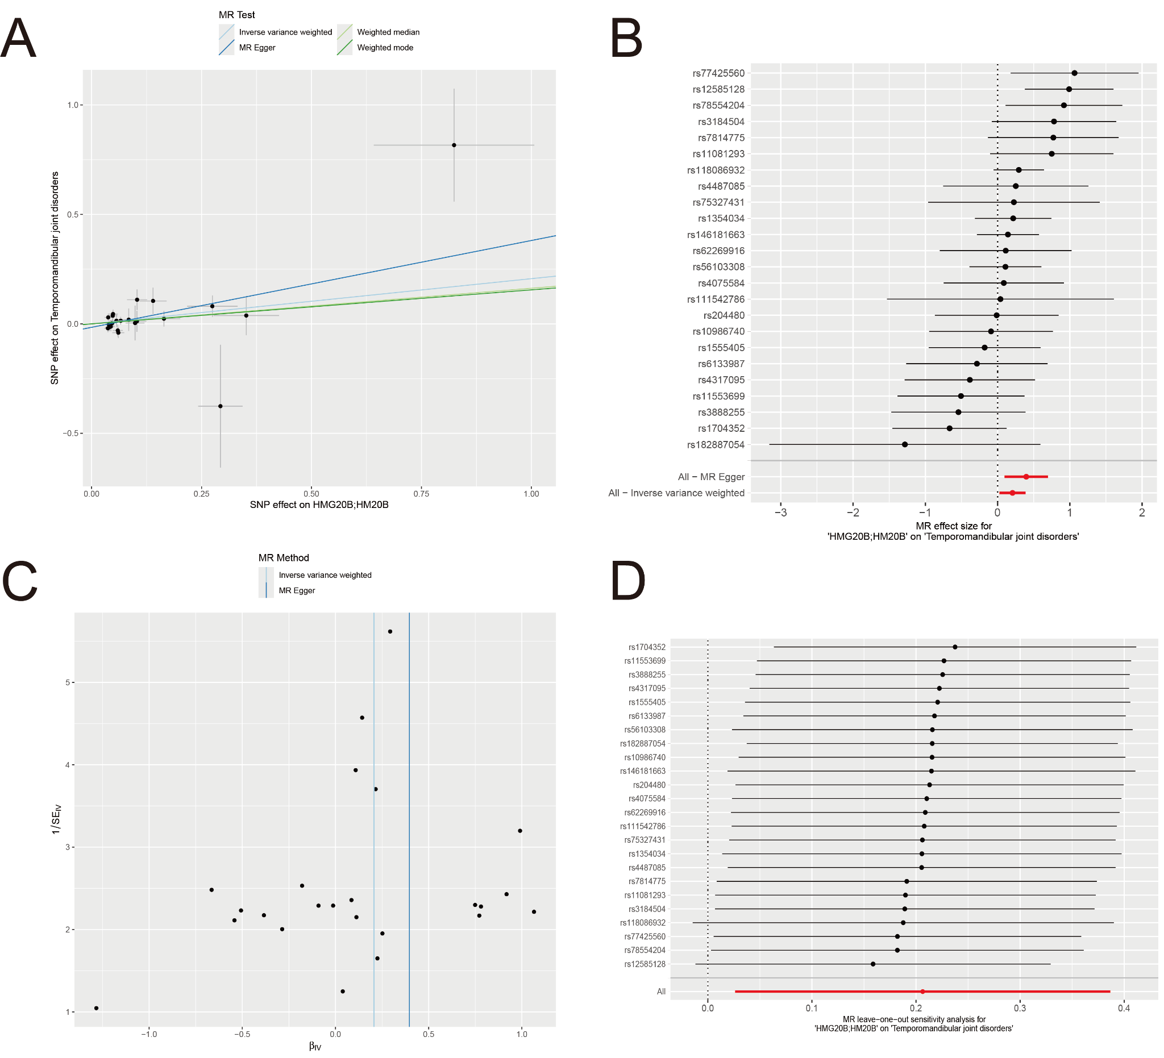
Supplementary Fig. 1. Sensitivity analyses for the HMG20B pQTL-based MR analysis of temporomandibular joint disorders. (A) Scatter plot showing the causal effect estimates of different MR methods, including inverse-variance weighted (IVW), MR-Egger, weighted median, and weighted mode. (B) Forest plot showing the effect estimates of individual SNPs and the overall estimates from the IVW and MR-Egger methods. (C) Funnel plot used to assess the symmetry of individual SNP effect estimates and to visually evaluate potential heterogeneity. (D) Leave-one-out analysis showing the influence of each single SNP on the overall causal estimate. MR, Mendelian randomization; pQTL, protein quantitative trait locus; SNP, single nucleotide polymorphism.
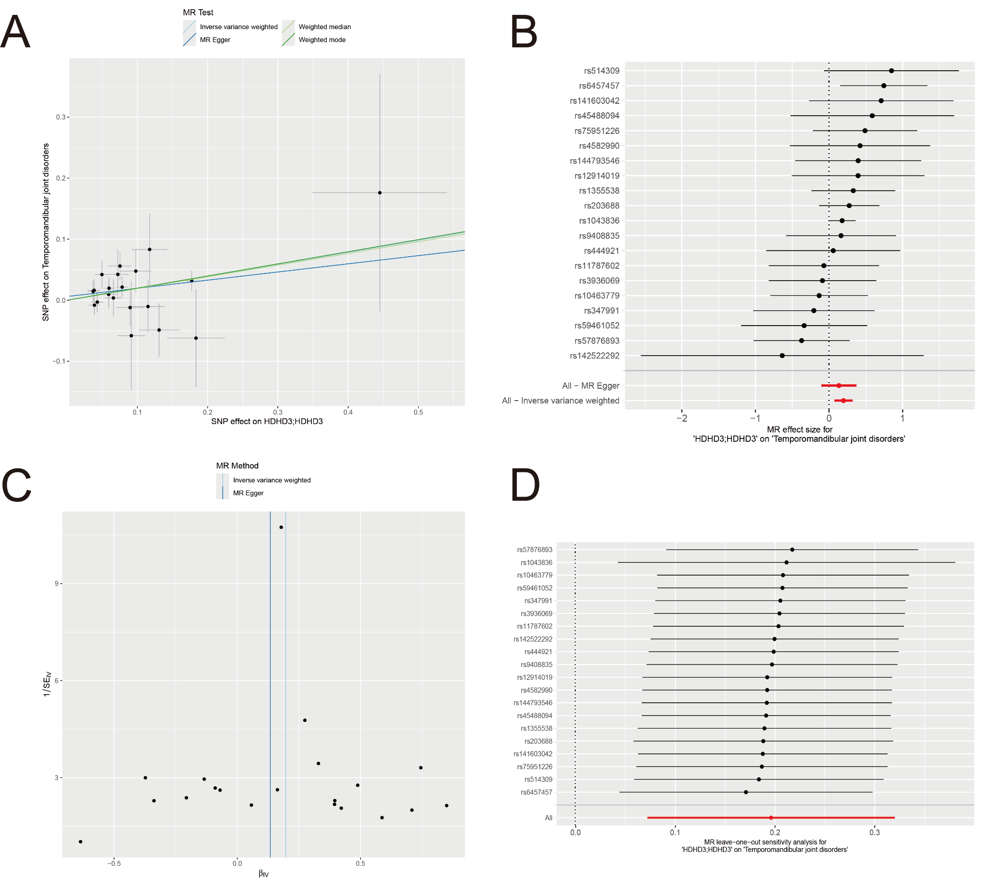
Supplementary Fig. 2. Sensitivity analyses for the HDHD3 pQTL-based MR analysis of temporomandibular joint disorders. (A) Scatter plot showing the causal effect estimates of different MR methods, including inverse-variance weighted (IVW), MR-Egger, weighted median, and weighted mode. (B) Forest plot showing the effect estimates of individual SNPs and the overall estimates from the IVW and MR-Egger methods. (C) Funnel plot used to assess the symmetry of individual SNP effect estimates and to visually evaluate potential heterogeneity. (D) Leave-one-out analysis showing the influence of each single SNP on the overall causal estimate. MR, Mendelian randomization; pQTL, protein quantitative trait locus; SNP, single nucleotide polymorphism.

